
CALIFORNIA TUMOR TISSUE REGISTRY
Proudly Announces the 139th Semi-Annual Pathology Cancer Seminar:

“Updates in the Changing World of Breast Pathology”

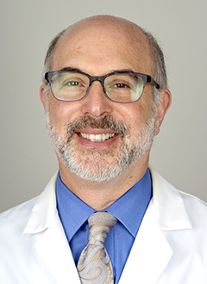
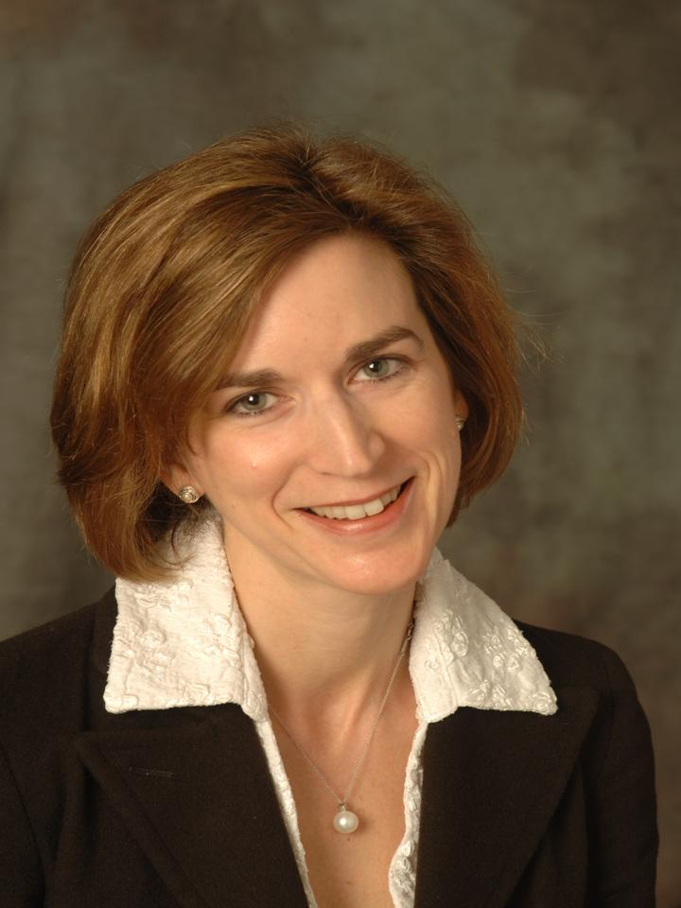
Laura C. Collins, MD
&
Stuart J. Schnitt, MD

December 6, 2015
8:30 a.m. – 4:45 p.m.

Hyatt Regency San Francisco

5 Embarcadero Center

San Francisco, California, 94111
Phone: (415) 788-1234

Seminar Objectives: At the conclusion of this seminar, attendees will be able to:
- To discuss the diagnostic features and differential diagnosis of several commonly encountered problems in breast pathology.
- To describe the diagnostic features and clinical significance of a variety of breast lesions with particular reference to the implications of these diagnoses in core needle biopsy specimens.
- To discuss the molecular classification of breast cancer and the uses and limitations of immunohistochemical surrogates to determine molecular subtype.
- To describe the current role of ancillary molecular testing in breast pathology.

Materials: (“Attendance Only” includes items 1 and 2)
1. 6 hour lecture (Covers seminar objectives, correlate clinical histories, discuss the role of special studies in diagnosis, therapy,
and counseling, and project photographs of the study cases and other illustrative materials)
2. Comprehensive syllabus that includes diagnoses, discussion, and appropriate references from pertinent medical literature
3. Glass slides of representative tumors.
CME/SAMs applies only to the day of the seminar. Full Package can earn up to 10 hrs CME and/or SAM, Attendance only can earn up to 6 hrs CME/SAM. This activity has been planned and implemented in accordance with the Essential Areas and policies of the Accreditation Council for Continuing Medical Education through the joint providership of Loma Linda University School of Medicine and California Tumor and Tissue Registry. The Loma Linda University School of Medicine is accredited by the ACCME to provide continuing medical education for physicians. Loma Linda University School of Medicine designates this Live Activity and Enduring Material for a maximum of 10 AMA PRA Category 1 Credit(s) TM. Physicians should claim only the credit commensurate with the extent of their participation in the activityThe American Board of Pathology also certifies this activity to provide up to 10 hours of SAM credit (Self Assessment Module). Disclosure Statement: This program has been planned and implemented in accordance with ACCME essentials and standards. The Loma Linda School of Medicine Office of Continuing Medical Education relies on its CME faculty to provide program content that is free of commercial bias. Therefore, in accordance with ACCME standards, any faculty and/or provider industry relationships will be disclosed and resolved.

PRACTICING PATHOLOGIST |  | RESIDENCY  TEACHING PROGRAM |  | RETIRED PATHOLOGIST & RESIDENT/FELLOW
Current Subscribing Member, Full Package (slides & syllabus)  Non-Subscribing Member, Full Package (slides & syllabus) | _______  $350.00  ______  $370.00 | Full Package (slides & syllabus) | _______  $275.00 | Full Package (slides & syllabus)  Retired Attendance Only | _______  $250.00  _______  $230.00
Attendance Only | _______  $250.00 | Attendance Only | _______  $250.00 | Resident/Fellows Attendance Only *with letter verifying residency status | _______  FREE*
* With a letter verifying residency/fellowship status ** For orders outside the United States of America, please add $40.00
+ Cancellations subject to a 15% overhead charge

Registration Form: (complete and mail, fax, or call CTTR)
Name:
Facility: Please Circle: Check (mail) Visa Master Card
Address: Name on Card:
P.O. Box: Credit Card number:
City, State, Country: Expiration Date: Zip code of billing address:
Zip: Phone: First four numbers of credit card billing address:
Fax: Total Amount:

Signature for Credit Card Authorization:
California Tumor Tissue Registry
11021 Campus Avenue, AH 335
Loma Linda, CA 92350
Phone: (909) 558-4788 / Fax: (909) 558-0188
CTTR@linkline.com

